CIS 635 Data Mining Name ___Dhynasah Cakir_

Homework 3

Hand in sheet

Write in or copy and paste the answers for the following:

**Part A**

1. a __65.7_____  
     
   b group 1 ___66.3______ group 2____73.5____ group 3____84.7___
2. __105 __________________
3. ____temperature and gender_______________________________________________

**Part B**

1. a. ______5000_______________  
     
   b. __________51% chance___  
     
   c. ___________95%_______________
2. a. attach to this document b. generally yes. But the pulse histogram does have a slight bimodal appearance.
3. a – d. attach to this document e. ______heart rate_____________
4. a. attach to this document b. ____________yes. It seems most of those with the virus have a higher heart rate.________________
5. a – b. attach to this document c. ____no. not really the number are too close to tell. __

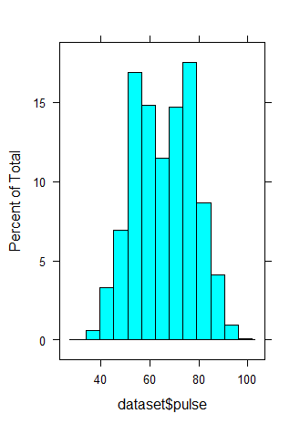

|  |  |  |  |
| --- | --- | --- | --- |
|  | Virus | |  |
| Gender | N | | Y |
| F | 1127 | | 1430 |
| M | 1315 | | 1128 |
|  | | Virus | | |  |
| Age Group | | N | | | Y |
| 1 | | 828 | | | 837 |
| 2 | | 798 | | | 825 |
| 3 | | 816 | | | 896 |